|  |
| --- |
| Schedule |
| Oct. 25th Friday |

|  |  |
| --- | --- |
| 14:00~20:00 | Registration at the reception hall of Shaoyuan Building 7 |
| 15:00~17:00 | Public lecture at Ding Shisun Hall, Zhihua Building  数学中分类问题的复杂性  Su Gao (Nankai University) |

|  |
| --- |
| Oct. 26th Saturday Unshaded events at Hongya hall, shaded events at Boya Hall |

|  |  |  |
| --- | --- | --- |
| 8:30~9:00 | Opening | |
| 9:00~10:00 | Title TBA  Natasha Dobrinen (Notre Dame University) | |
| 10:15~11:15 | From model theory to mathematical economics  Yeneng Sun (National University of Singapore) | |
| 11:30~12:10 | Title TBA  Bokai Yao | The determinacy strength of probabilistic  omega-languages  Wenjuan Li |
|  | Lunch | |
| 13:45~14:45 | Definable combinatorial principles in fragments of arithmetic  Wei Wang (Sun Yat-sen University) | |
| 15:00~15:40 | Embedding Borel graphs into grids  Jing Yu | Splitting properties in 3-c.e. degrees  Yong Liu |
| 15:40~16:20 | An order analysis of hyperfinite Borel equivalence relations  Ming Xiao | Multiple applications of fully first order problems  Daniel Mourad |
| 16:35~17:15 | On groups definable in p-adically closed fields  Ningyuan Yao | Doing logic like doing physics: a logical theory of conditionals and modals  Xuefeng Wen |
| 17:15~17:55 | Amalgamation and existential closedness of  valued difference fields  Jan Dobrowolski | Axiomatization of modal logic with complementary operator and Boolean modal logic  Chenwei Shi |

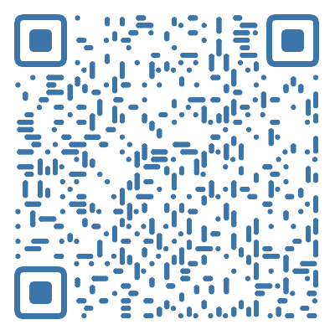

|  |
| --- |
| Oct. 27th Sunday Unshaded events at Hongya hall, shaded events at Boya Hall |
| |  |  |  | | --- | --- | --- | | 9:00~9:40 | Existence of Kim-independence in NSOP1 theories over sets  Joonhee Kim | The surprise exam in full modal fixed-point logic  Yanjun Li | | 9:55~10:55 | Topological models of provability logic  Lev Beklemishev (Steklov Institute of Mathematics, RAS) | | | 11:10~12:10 | Word structures and their automatic presentations  Bakh Khoussainov (University of Eletronic Sciences and Technology of China) | | | 12:10~12:30 | Closing | | |
| Full Program and abstracts at https://voidprove.github.io/cacml2024/program/  Or you can scan the QRcode on the right. |